Lodging a Combined Certificate Application

- Click on Submit an Application:

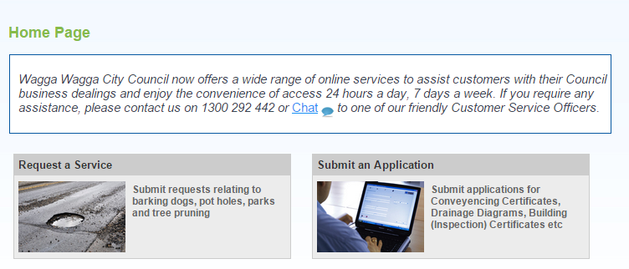

- Select “Online Combined Certificate” (Note: Use the Debtors option if you have a Debtor Account):

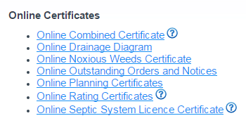

- Tick the certificates that are required and click next:

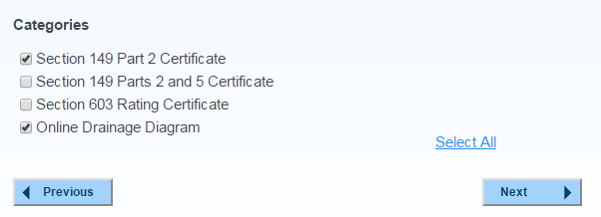

- Enter the details as per the below example and click Next. If you would like a GIPA request lodged also for the property, ensure that you indicate that you would like a GIPA:

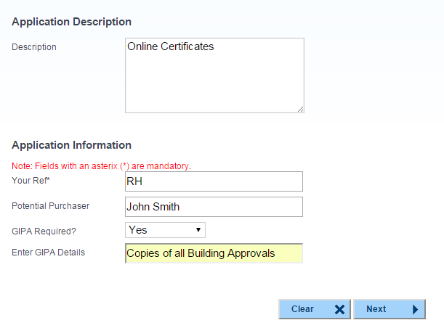

Note: If the GIPA details do not fit within the “Enter GIPA Details” field, enter the details in the “Description” field at the top of the page.

- Enter one or more email addresses to receive the certificates and/or GIPA, and click Add. Click Next when all emails have been entered:

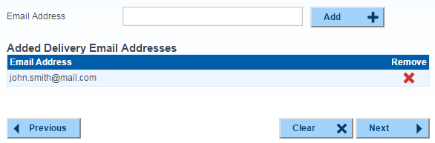

- Enter the property details and click search. Ensure that the correct property is selected and click next:

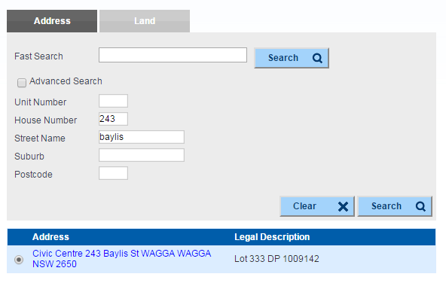

- Ensure the summary details are correct and click Continue. The Amount Due will be a total of the charges raised depending on the certificates selected.

- Tick the correct charge within the Shopping Cart and click Proceed to continue:

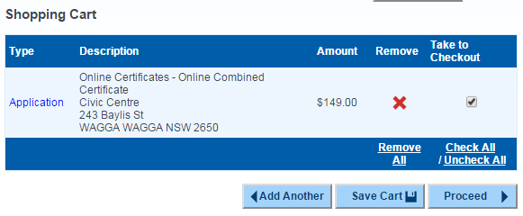

- Enter your name and contacts details for the Certificate. If you are a logged in user these details will be automatically populated.

- Enter your Credit Card details to make the payment. If you have a Debtor account (and have logged in), you will have the option to assign the charges to your Debtor account.

- Click Next once all details have been added (your credit card or debtor account will not be charged until the next step is completed).

- Verify the details on the final page and click Complete when finished. Your Credit Card or Debtor Account will be charged at this stage.

